- The Huge Offer

The Huge Offer represents a 33% premium on the 30-day weighted average traded price (as defined in the JSE Listings Requirements) of Adapt IT Shares on the trading day immediately preceding the date of the Huge Offer, being 27 January 2021.

- The rationale for making the Huge Offer and the benefits to Huge Shareholders and Adapt IT Shareholders

- Introduction: “Better-off together”

Like shareholders of any company, Huge Shareholders expect shareholder returns, as evidenced by dividends, an increasing share price and growth in the value of their Huge Shares. The Huge Board and the Adapt IT Board can generate shareholder returns through the organic growth of the portfolio of companies over which they have influence, or by increasing the size of the portfolio of companies under their influence through acquisition. Either way, investment scale, reflected by an ever-increasing market capitalisation, and an appreciating share price, is very important if a company wants to meet shareholder expectations.

Huge and Adapt IT are facing headwinds in the further development of their respective portfolios of companies. Organic revenue growth in the last 24 months has been pedestrian, which implies that growth through acquisition is key. Relative to larger market capitalisation companies listed on the JSE, the Huge Board believes that:

- The share prices of their respective companies do not reflect underlying intrinsic value;
- The tradability of the Huge Share relative to Adapt IT Share is low; and
- In the case of Adapt IT, it has relatively high levels of interest-bearing debt on its balance sheet, which increases the perception of risk.

These factors, largely attributable to limited investment scale, have an impact on investment appeal and result in a Value Gap. Furthermore, if listed companies cannot raise equity capital, or can only do so at prices less than their intrinsic value, then they are unable to fund acquisitions using equity in a non-value-dilutive way. The options that are available to larger market capitalisation companies are either not available to Huge and Adapt IT, or pricing is punitive, limiting the extent to which Huge and Adapt IT can grow, optimise their portfolios of companies, extract return-enhancing synergies and generally pursue acquisitive growth. Therefore, the value of investment scale certainly informs the Huge Offer.

On a positive note, Huge and Adapt IT are both cash generative, high margin, annuity revenue companies with lower risk profiles than many other investment alternatives. Huge and Adapt IT will grow as standalone entities, but the Huge Board certainly believes that they can grow faster together than apart. The Huge Board is of the view that Huge and Adapt IT are ‘better off together’; make for a compelling investment story on a combined basis and can deliver greater shareholder returns together.

The strategic rationale underpinning the Huge Offer can be summarised as follows:
- The value of investment scale delivered through Huge-Adapt IT Merger
- Attractive synergies, fit and alignment between the businesses
- Greater customer “real estate”, reach and growth opportunities
- An enhanced profile, greater investor confidence and better access to capital – whilst lowering the combined cost of capital
- Improved equity market trading performance
- Creating a larger, lower cost, more profitable business with the potential to recognise other cost synergies and efficiencies
- Expanding the collective base of reference shareholders and management executives

The paragraphs below focus on each of these elements in more detail.

- Alignment, fit and synergy

- Huge’s raison d'être

Huge owns and acquires meaningful interests in businesses in the converging connectivity, cloud, software and x-Tech markets.

Its mission statement is as follows:

“We:
- Focus on the strategic management of our existing businesses and expanding our portfolio through acquisition
- Amplify value by leveraging our customer ‘real estate’ and the scale of the broader Huge ecosystem
- Empower and support our partners who lead the businesses
- Facilitate collaboration between our entities”

Huge has the right people to make this happen.

The benefits of this inter-connectivity, the strategic support and management support offered by the Huge Board, coupled with the fact that the underlying businesses within our network are nurtured and encouraged to grow in line with its own unique culture and strategy, means that Huge has the optimal platform - and individuals - to succeed when bringing the two groups together.

- Nature of Adapt IT’s business

As set out in the 2020 Adapt IT Integrated Report, Adapt IT provides leading specialised software and digitally led business solutions that assist clients across targeted industries to achieve more by improving their customer experience, core business operations, business administration, enterprise resource planning and public service delivery.
Adapt IT has deep sector knowledge and experience in the education, manufacturing, financial services, energy, technology expense management (multi-industries), telecommunications, consumer security and services, and hospitality industries, including the public sector.

Adapt IT serves over 10 000 global customers, with headquarters in Johannesburg, South Africa, and regional offices in Durban and Cape Town. To service international customers, Adapt IT focuses on the pan African market, through a presence in Mauritius, Botswana, Kenya and Nigeria, as well as on the Asia Pacific market, where the group has a presence in Australia, New Zealand and Singapore. Through its presence in Ireland, Adapt IT is also able to service customers in Europe.

- Examples of the synergy, fit, and alignment of the Huge-Adapt IT Construct

The Huge Board believes that the Huge-Adapt IT Construct is a ‘match-made-in-heaven’, since:
- The businesses of Huge and Adapt IT are aligned;
- There is very little overlap; and
- There is visible synergy from which value can be created.

Examples of the alignment between Huge and Adapt IT are set out below:
- Adapt IT’s communications division is a telecommunications solutions provider, providing specialist proprietary software and value-added services to the telecommunications industry, which is offered across mobile network operator core networks and range from next-gen VAS through to data analytics, IoT management, customer experience, self-service and mobility. Through AspiviaUnison, Adapt IT provides expense management software services to customers who have telephone systems.

- Huge Connect, Huge Networks, and Huge Telecom are telecommunications service providers who provide a comprehensive range of connectivity solutions across all mediums, including connectivity solutions across mobile networks. The cloud and the delivery of SaaS would be still born if there was no connectivity. Huge Connect and Huge Telecom’s strategic advantage lies within each of their respective billing engines, which provide tailored price plans to over 48 000 customers.

- Huge Connect provides payment connectivity to over 30 000 merchants, including retailers and more specifically hospitality retailers, who have point-of-sale software and devices, while Huge Software licences proprietary accounting and ERP software. Adapt IT’s hospitality division, through Micros South Africa, specialises in the resale, support, and deployment of software and hardware products, including cloud solutions and the provision of professional services, to these very customers, which implies that there are strong synergies between these three companies.

- Adapt IT could also leverage the contracts and great relationships Huge Connect has with the large commercial banks to build on its terminal automation solutions, mobile point-of-sale offerings, and mobile money and mobile wallet applications to an enlarged customer base.

- Huge Software’s WebAccounting accounting software and CQS’s Caseware audit and risk software fit very well together, complement each other, and can be leveraged. Adapt IT’s financial services division provides a range of software solutions that automate financial statement and assurance engagements, streamline tax management processes, and enable simplified time and billing management for about 4 500 audit and accounting firms, government entities, municipalities and large companies across Africa. Adapt IT is an ideal partner for Huge Software’s ERP offerings to the mid-tier market. This gives Adapt IT an additional service partner who can supply ERP software to those clients that do not want to go to a SAP, Oracle or Microsoft ERP solution. This will create new market opportunities for Adapt IT and Huge Software for selling Huge Software’s ERP solutions.

- Huge Distribution is an importer of hardware from various large international companies. These relationships could be leveraged in the areas in which Adapt IT operates.

Furthermore, the Huge-Adapt IT Construct creates the opportunity to unlock value in the data, software, voice and hosting space. Market verticals currently serviced by Adapt IT, such as education, would benefit from Huge Network’s ability to deliver high-capacity connectivity. The convergence of Adapt IT’s SaaS in the cloud and the connectivity offerings of Huge, allow for the end-to-end delivery and management of SaaS, voice or data, and IoT offerings, giving the customer comfort that their provider has control over and is responsible for the entire value chain.

- An enlarged real estate of customers, greater customer reach and growth potential

Digital platforms or networks that facilitate connections and exchanges is an important modern concept. This trend is turning established business models on their heads, requiring many traditional businesses to transition to, or incorporate, a platform-based model. This combined with the network effect (the phenomenon whereby the value of services increases exponentially by the number of participants) suggests that Huge’s central tenet of growing its real estate of customers is a value creation imperative. Enlarging Huge’s customer base to over 60 000, by combining Adapt IT’s 10 000 existing customers with Huge’s 50 000 existing customers, would increase the value of this proposition.

As such, the Huge-Adapt IT Construct will enable the convergence of customer bases, product sets, and provide access to new markets, which will in turn facilitate potential increases in market shares. Huge can open its base of customers to Adapt IT, providing Adapt IT with additional market segments in which it has not historically participated including, but not limited to, medical, retail, building & hardware and automotive.

- Macro-economic considerations relating to Adapt IT, Huge and the Huge-Adapt IT Construct

- The South African micro-cap market and access to growth capital

Despite the economic downturn in 2020, the Covid-19 pandemic has served to accelerate global trends such as remote work, digitisation, e-commerce, and associated services. Covid-19 has also made things happen faster, which means that speed and scale are crucial to capitalise on the accelerated evolutionary impact of the pandemic. To capitalise on this opportunity, critical mass is crucial. In addition, acquisitive growth is essential to underpin sustainable growth strategies.

Small and micro-cap shares in the South African market (the market for shares listed on the JSE) have performed poorly over the past three years. Both Huge and Adapt IT have delivered a negative three-year return profile – with Adapt IT Shares down 43% and Huge Shares down 24% (calculated on 8 March 2021). Over the past five years, Adapt IT Shares are down 62%, while Huge Shares are up 25% (calculated on 8 March 2021).

While we see more money flowing into equity markets than ever, these funds are certainly not yet reaching South African micro-cap stocks and might well not for the foreseeable future.

In this market, investors are looking for:
- Critical mass;
- Efficient and well-managed organisations with a convincing strategy;
- Growth plans and mergers reflecting clear underlying synergies and strategy; and
- Entities that have a far greater chance of attracting the new or pending emerging market investment wave of funding.

The Huge-Adapt IT Construct is founded on a principle of ‘better off together’ by virtue of its combined and enlarged customer “real estate” and the ability to attract new institutional shareholder interest. Size, speed, and flexibility matter in this evolving environment. In addition, the combined currency of a Huge-Adapt IT Construct will enable the Enlarged Entity to become a more active participant in M&A activity.

The Huge-Adapt IT Construct will result in a larger organisation, increasing investment scale, and greater investor confidence. This will lead to easier access to capital markets for expansion and further acquisitions in Huge and Adapt IT’s chosen markets, both in South Africa and abroad. Huge’s recent announcement about plans to seek an AIM Listing on the London Stock Exchange may also offer the Enlarged Entity easier access to foreign capital markets.

The Enlarged Entity will facilitate faster strategy implementation. There is an opportunity for the Enlarged Entity to become the ICT investment of choice in South Africa and Africa, especially given the absence of other listed comparable companies.

Huge and Adapt IT have both increased their respective profiles because of the Huge Offer. The Enlarged Entity will, to an even greater extent, also increase its profile and investor interest.

- The importance of investment scale

In South Africa, investor appetite for smaller market capitalisation companies is at a low with no evidence of a near-term change in sentiment. Immediately prior to the Huge Offer, the Huge Shares traded at a price of 613 cents per share, giving it a market capitalisation (ignoring treasury shares) of R1.02 billion, while Adapt IT Shares traded at a price of 399 cents per share, giving it a market capitalisation (ignoring treasury shares) of R0.55 billion. At the Huge Offer Price, Huge values Adapt IT at R0.76 billion. At this date, the combined market capitalisation of Huge and Adapt IT was R1.57 billion, while immediately after the Huge Offer, the combined market capitalisation of Huge and Adapt IT was R1.78 billion. On 8 March 2021, the combined market capitalisation of Huge (measured at its closing price) and Adapt IT (measured at the Offer Price) was R1.92 billion. The Huge Board is of the view that this market valuation can be maintained - if not increased - if the level of Huge Acceptances is high. For illustrative purposes, on the assumption that the Huge Acceptances is 100%, a Huge Share trading at 700 cents per share will imply, at the Swap Ratio, a value per Adapt IT Share at 630 cents and a combined market capitalisation of R2.08 billion.

These calculations have not been reviewed by Huge’s auditors and are the responsibility of the Huge Board.

- Micro-economic considerations relating to Adapt IT, Huge and the combination of Huge and Adapt IT

- The Huge-Adapt IT Construct will eliminate target company competition

The market for target companies in connectivity, cloud, software, and x-Tech is extremely competitive, and acquisition targets are becoming scarce. Huge and Adapt IT currently do, and will continue to, compete for the same target companies. Combining both companies will eliminate competition between Huge and Adapt IT for target companies in the market for connectivity, cloud, software, and xTech. It is also probable that the Enlarged Entity may enjoy increased M&A deal flow.

- A Huge-Adapt IT Construct has positively impacted, and will continue to positively impact, tradability and liquidity

There is no investor appetite for illiquid companies or companies whose shares do not trade frequently on their chosen stock exchange. In a volatile environment, the ability to turn listed share investments into cash has become significantly more important to the retail and institutional shareholder.

Today, the trade in the Huge Share is less than that in the Adapt IT Share. However, this has not always been the case. The trade in the Huge Share was greater than the trade in the Adapt IT Share from 2007 to 2011, while since 2012 trade in the Adapt IT Share has been greater.

The Huge Board believes that tradability can and needs to be distinguished from liquidity. The Huge Board believes that, although the tradability of Huge Shares on the JSE is low, it does not mean that a Huge Share is illiquid. To understand this statement, one needs to look at the spread or lack of spread (concentration) in the Huge Share Register. On 26 February 2021, the Huge Share Register disclosed the details of 1 060 Huge Shareholders. On the same day, the Adapt IT Share Register disclosed the details 12 647 Adapt IT Shareholders.

The Huge Board is of the view that the Adapt IT Shareholders should consider that 89% of the Huge Shareholders are represented by five parties. The Huge Board’s view is that while this concentration might mean that the Huge Shares trade less on the JSE, it does not mean that the Huge Share is illiquid and cannot be converted to cash readily. Also, on the assumption that the Huge Acceptances is 100%, the 12 647 Adapt IT Shareholders (as at 26 February 2021) on the Adapt IT Share Register will become shareholders of the Enlarged Entity and they will appear on the Enlarged Entity’s Huge Share Register. As such the tradability and liquidity of the Adapt IT Share will be transferred to Huge. It cannot be disputed that by combining the Huge Shareholders and the Adapt IT Shareholders into an enlarged Huge Share Register, the liquidity and tradability of the Huge Share will be better than the liquidity and tradability of either the Huge Share or the Adapt IT Share before the combination.

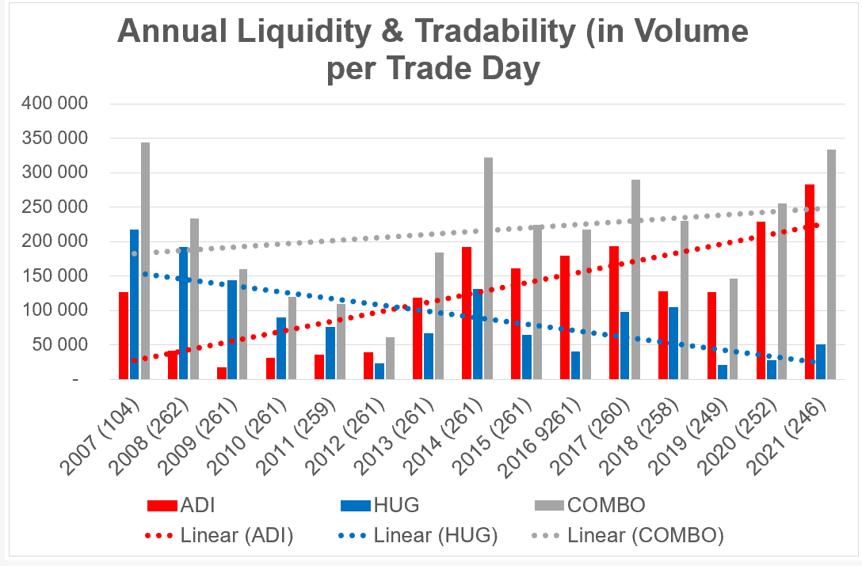
Source: Standard Bank Online Share Trading

- The corporate activity initiated by the Huge Offer has had a positive impact on the tradability and the price of an Adapt IT Share

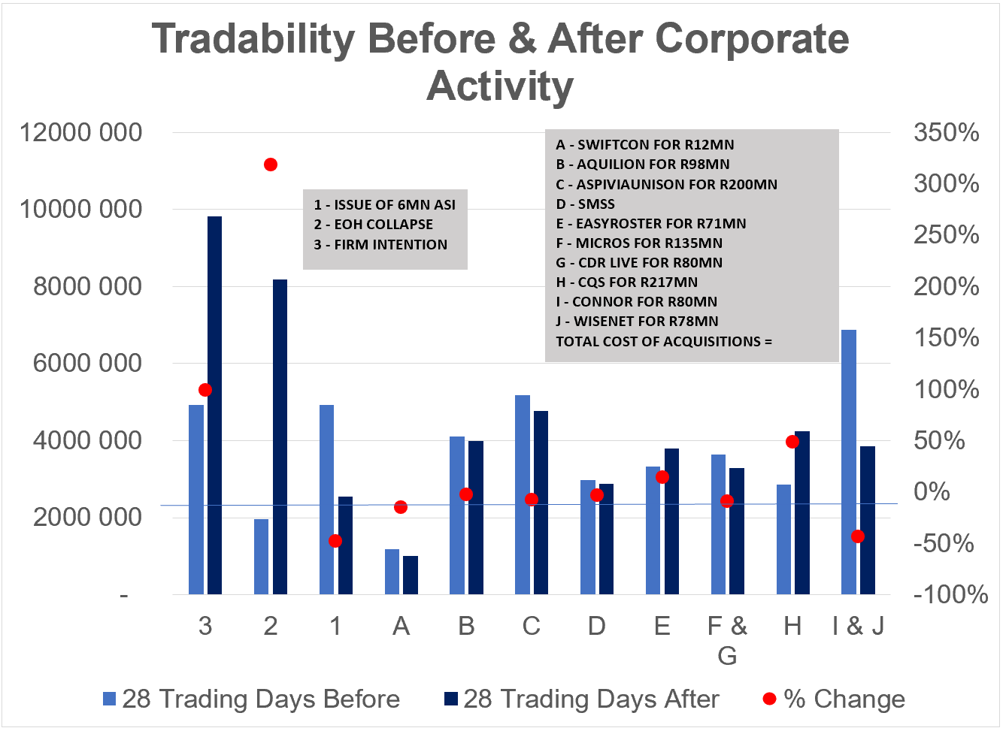
Source: Standard Bank Online Share Trading

The tradability of an Adapt IT Share 28 days before and after a corporate event is depicted in the graph included above.

The Adapt IT Share price performance relative to the Huge Share price performance is illustrated below.

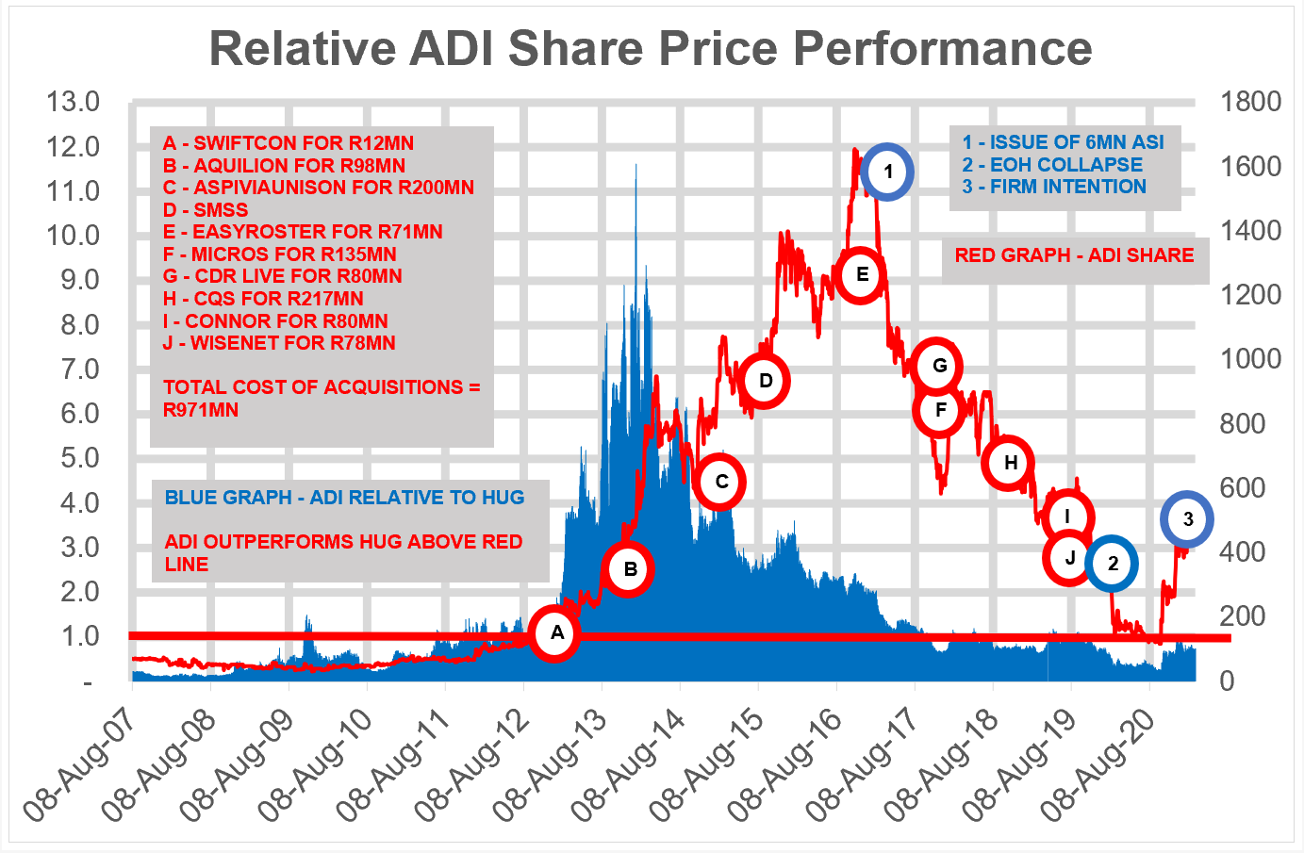
Source: Standard Bank Online Share Trading

It is unclear from the two graphs inserted above whether Adapt IT’s corporate activity in the past has improved or worsened tradability and/or whether or not the market responded positively to a particular transaction. In many cases, following Adapt IT corporate activity, the volume of Adapt IT Shares traded declined. In recent years, following Adapt IT’s acquisition of CQS (Labelled H), the volume of Adapt IT Shares traded increased significantly in the 28 days after the announcement of the corporate event. However, this should be considered with the conclusions that can be drawn from a declining Adapt IT Share price. The volume of Adapt IT Shares traded post the Huge Offer nearly doubled in the 28 days after the announcement, when compared to the 28 days before the announcement, and this is evidence that corporate activity matters. In the 28 days after the announcement, 7.15% of Adapt IT’s share capital (ignoring treasury shares) changed hands, which implies that 85.8% of Adapt IT’s shares could potentially change hands in a single calendar year.

- A Huge-Adapt IT Construct will create a larger, lower cost, more profitable investment

A Huge-Adapt IT Construct provides investors with a relatively inexpensive and low-risk technology investment where a material component of revenue is annuity based. Compounding is the 8th wonder of the world and with annuity revenue; this wonder can be realised.

 | Adapt IT | Huge | Better Together
 | June 2020 | February 2020
 | R | R | R
Revenue | 1 483 346 995 | 492 144 782 | 1 975 491 777
Cost of sales | (661 285 411) | (183 908 789) | (845 194 200)
Gross profit | 822 061 584 | 308 235 993 | 1 130 297 577
Operating expenses net of other income | (624 874 612) | (172 317 225) | (797 191 837)
Profit from operations | 197 186 972 | 135 918 768 | 333 105 740
Finance income | 2 332 399 | 3 717 046 | 6 049 445
Finance costs | (84 698 847) | (21 573 045) | (106 271 892)
Profit before tax | 114 820 524 | 118 062 769 | 232 883 293
Income tax expense | (44 028 610) | (22 739 080) | (66 767 690)
Profit for the year | 70 791 914 | 95 323 689 | 166 115 603

On a proforma basis, the Enlarged Entity would have a gross margin of 57.2% (with reference to the 2020 Adapt IT Integrated Report and the 2020 Huge Integrated Report). Using the financial information in these reports, Adapt IT’s gross margin of 55.4% would be enhanced by Huge’s gross margin of 62.6%. The Enlarged Entity would also have a lower cost structure, where operating costs (net of other income) as a percentage of revenue would be 40.4%. Adapt IT’s cost structure, which is 42.1% of revenue, would be reduced because of Huge’s lower cost structure, which is 35% of revenue. We note that these illustrations do not take into account any other cost reductions or synergies.

- A Huge-Adapt IT Construct will lower the cost of capital

Diversification lowers the cost of capital, which has an inverse relationship with equity values. In other words, the lower the cost of capital the higher the value of equity. Huge and Adapt IT have significant levels of goodwill. The higher the cost of capital, the higher the discount rate that present values future cash flows, and the greater the risk of goodwill impairments, which will have a negative effect on earnings.

- A Huge-Adapt IT Construct will create cost savings and efficiencies

On the assumption that the Huge Acceptances is 100%, duplicate listing and other corporate costs can be eliminated. The cost of running Huge as a listed company with a holding company and head office structure is approximately R20 million a year. At the very least, and from Huge’s vantage point, these duplicated costs can be eliminated. In addition, there are arguably other corporate costs that can be reduced, if not eliminated, such that additional earnings can be unlocked for the Enlarged Entity.

- A Huge-Adapt IT Construct will increase expertise and manpower

Huge has an exceptionally skilled M&A team, who have a proven track record of highly innovative M&A transactions informed by various strategies, efficiencies and managed risk-taking. This can only benefit future growth and M&A potential for an Enlarged Entity and bring an exciting dynamic to an enlarged team. It is arguable that both Huge and Adapt IT require more manpower capacity for M&A. A combined Huge and Adapt IT will enhance the Enlarged Entity’s M&A skills. It appears that Adapt IT’s M&A skills lie with Ms Koffman, who is a non-executive director of Adapt IT, and Mr Shabalala and Mrs Dunston, who are both executives of Adapt IT, while Huge’s M&A skills lie with Dr da Silva, Prof. Armstrong, Mr Lyons, Mr Gammie, who are all non-executive directors, and Mr Herbst and Mr Openshaw, who are Huge executives. The combination of these nine individuals brings a powerful M&A team to the market with a proven track record of creating value for stakeholders over many years.

Huge’s strategy for acquiring companies involves “backing the jockeys” in each target company, ensuring that each operating entity has the correct individual driving the teams and with skin-in-the-game. This strategy has yielded effective results for Huge and this has been proved during the Covid-19 pandemic, where all of Huge’s’ operating entities performed exceptionally well considering the circumstances. This is testimony to the success of Huge’s approach. No staff retrenchments and salary cuts were instituted at Huge, which illustrates the resilience of each of Huge’s operating entities.

Adapt IT Proprietary Limited, the wholly owned subsidiary company of Adapt IT, has a BBBEE score of Level 1, even if the Huge Acceptances are 100%.

- A Huge-Adapt IT Construct might produce property utilisation benefits

The 2020 Adapt IT Integrated Report discloses the following related party information:

The Landlord of Adapt IT’s Johannesburg Campus is Mshengu Property Holdings Proprietary Limited (MPH). MPH is 100% owned by the Mshengu Family Trust. Mr Shabalala, the Chief Executive Officer of Adapt IT, is a beneficiary and trustee of the Mshengu Family Trust. Furthermore, Mr Shabalala is a director of MPH. It appears from the 2020 Adapt IT Integrated Report that The Johannesburg Campus is under a 13-year lease.

Five of Huge’s operating companies occupy premises in three locations in Johannesburg. Huge only concludes lease agreements of short duration. While some of the leases span as many as three years, Huge has an option to give early termination notice. These short leases allow Huge, subject to the return to a normal work from office world post Covid-19, to move to Adapt IT’s Johannesburg Campus in the event that it has spare capacity, thereby reducing duplicate costs.

- Additional benefits for Adapt IT Shareholders

- The Huge Offer resulted in an immediate increase in the price of an Adapt IT Share

Because the Huge Offer better reflects the underlying intrinsic value of an Adapt IT Share, it has narrowed (and continues to narrow) the Adapt IT Value Gap. It is arguable that the lower the Huge Acceptances, the more likely it is that the Adapt IT Share will revert to a pre-Huge Offer price.

- A Huge-Adapt IT Construct will broaden the base of reference stakeholders

Adapt IT’s reference shareholders include, in order of shareholding, Nedgroup, Sanlam and the PIC. Huge’s reference shareholders include, in order of shareholding, Praesidium, Stanlib and Sentio. Combining the base of reference shareholders can only be positive for existing Huge Shareholders and future Huge Shareholders (being Adapt IT Shareholders that accept the Huge Offer).

Adapt IT’s debt providers include Standard Bank and FirstRand. Huge’s debt providers include FirstRand, Futuregrowth and Rand Merchant Bank. Similarly, combining the base of reference debt providers can only be positive for the Huge-Adapt IT Construct.

- A Huge-Adapt IT Construct will create a stronger balance sheet

An organisation’s capital structure is critical and should allow it to be optimally positioned to take advantage of favourable lending rates, while also considering the risk of over gearing should a low interest rate regime reverse. A Huge-Adapt IT Construct would be more favourably perceived by lending institutions and would better position the Enlarged Entity to withstand any monetary policy reversal. Accordingly, if the Huge Acceptances are high, this presents Adapt IT Shareholders with an opportunity to lower their financial risk exposure, because the market value of Huge’s equity over its interest-bearing liabilities provides more cover when compared to the market value of Adapt IT’s equity over its interest-bearing liabilities.

Notwithstanding the global ZIRP (Zero Interest Rate Policy), there are growing inflationary concerns. Consequently, the debt/equity capital structures of organisations are crucial, and they need to be optimally positioned to take advantage of favourable lending rates and mitigate the risk of over gearing should low interest rate regimes reverse. The Huge-Adapt IT Construct will be more favourably perceived by lending institutions and the Enlarged Entity will be better positioned to withstand any monetary policy reversal. Huge currently has capacity to increase its own gearing.

On the day of Huge Offer Adapt IT’s market capitalisation of R0.55 billion (ignoring treasury shares) to interest bearing liabilities of R0.51 billion (per the 2020 Adapt IT Integrated Report) provided a cover of one times. On the other hand, on the same day, Huge’s market capitalisation of R1.02 billion (ignoring treasury shares) to interest bearing liabilities of R0.17 billion (per the 2020 Huge Integrated Report) provided a cover of six times. On the assumption that the Huge Acceptances is 100%, the combined cover of the Enlarged Entity will be three times (R1.92 billion divided by R0.68 billion). This must reduce the Adapt IT Shareholder’s perception, as well as other investor’s perception, of interest rate risk.

On 30 June 2020 Adapt IT held interest-bearing debt of circa R0.51 billion and it incurred interest costs of circa R48.5 million. For illustrative purposes, assuming a 4% increase in interest rates, Adapt IT’s profit after tax for the year ended 30 June 2020 would have declined by approximately 25% (or R17.4 million), from R70.4 million to R53.4 million. In other words, given its relatively high levels of debt, Adapt IT is negatively exposed to a higher interest rate environment. This will limit Adapt IT’s ability to fund acquisitions by taking on more debt.

Huge’s low level of debt compared to Adapt IT places the Enlarged Entity in a better position to continue to use debt to fund further acquisitions. In other words, it increases funding capacity because of lower levels of interest-bearing debt.

The Huge Offer presents an opportunity to create a larger entity with greater critical mass and enhanced liquidity, providing an improved platform to facilitate acquisitive growth.

- A Huge-Adapt IT Construct provides takeover protection

The Adapt IT share closed at 401 cents on the day of the Huge Offer and has been trading around 500 cents at the end of March 2021. The Huge Offer can be seen as a defensive strategy to an alternative (cash) offer which may not reflect Adapt IT’s intrinsic value. If an alternative new offer is accepted by some Adapt IT Shareholders this may place other Adapt IT Shareholders at risk of being forced to exit Adapt IT when there is a Value Gap. The same applies to a share for share offer by another large, listed company. If a large, listed company acquires Adapt IT, the Adapt IT Shareholder’s exposure to the underlying Adapt IT markets and businesses will be reduced.

Importantly to note, the Huge Offer is not hostile to Adapt IT shareholders. It allows them to retain a significant amount of exposure to Adapt IT’s underlying businesses while creating investment scale. The Huge Offer is made on the foundation of ‘better-off together’. It has been conceived on the basis of a merger rather than a takeover. It is also a way in which Adapt IT can grow by acquisition. Viewed from Adapt IT’s vantage point, it is a mechanism for Adapt IT, as a listed company, to create investment scale and grow by acquisition in the presence of a Value Gap.

- Conclusion: “Better off together”

A Huge-Adapt IT Construct creates a listed company investment:
- with greater investment scale and potentially a higher market capitalisation;
- with a broader base of reference stakeholders;
- whose shares are more tradable;
- with a proactive investment strategy;
- with an aggressive M&A, dealing-making bias;
- with better prospects for acquisitive growth.
- with lower levels of debt.

Glossary
2020 Adapt IT Integrated Report | The Integrated Report of Adapt IT for the year ended 30 June 2020.
2020 Huge Integrated Report | The Integrated Report of Huge for the year ended 28 February 2020.
Adapt IT | Adapt IT Holdings Limited (Registration No. 1998/017276/06), a public company duly incorporated in accordance with the laws of South Africa and listed on the JSE.
Adapt IT Board | The board of directors of Adapt IT as constituted from time to time.
Adapt IT Share | Ordinary no par value shares of Adapt IT, listed on the JSE’s stock exchange.
Adapt IT Shareholders | Shareholders of Adapt IT.
Adapt IT Share Register | The share register of Adapt IT.
Adapt IT Value Gap | The difference between the share price of Adapt IT when it is lower than its intrinsic value per share.
Enlarged Entity | Huge if it can consolidate Adapt IT.
ERP | Enterprise Resource Planning.
FirstRand | FirstRand Bank Limited.
Futuregrowth | Futuregrowth Asset Management Proprietary Limited.
Huge | Huge Group Limited (Registration No. 2006/023587/06), a public company duly incorporated in accordance with the laws of South Africa and listed on the JSE.
Huge Acceptances | The percentage of Adapt IT Shareholders who accept the Huge Offer.
Huge Board | The board of directors of Huge as constituted from time to time.
Huge Connect | Huge Connect Proprietary Limited (Registration No. 2004/005721/07), a private company duly incorporated in accordance with the laws of South Africa, and an 83.71% owned subsidiary company of Huge.
Huge Networks | Huge Networks Proprietary Limited (Registration No. 2014/009214/07), a private company duly incorporated in accordance with the laws of South Africa, and a 50.03% owned subsidiary company of Huge Telecom.
Huge Offer | The general offer made by Huge on 27 January 2021 in terms of S117 (c) (v) of the Companies Act to the holders of ordinary shares in Adapt to acquire all the issued Adapt IT Shares at a consideration equivalent to 552 cents per Adapt IT Share, to be settled by way of an issue of Huge Shares at a price of 613 cents per Huge Share, which translates into a swap ratio of 0.9 for each Adapt IT Share tendered.
Huge Offer Price | 552 cents per Adapt IT Share.
Huge Share | Ordinary no par value shares of Huge, listed on the JSE’s stock exchange.
Huge Share Register | The share register of Huge.
Huge Shareholders | Shareholders of Huge.
Huge Software | Huge Software Proprietary Limited (Registration No. 2005/042514/07), a private company duly incorporated in accordance with the laws of South Africa, and a 75% owned subsidiary company of Huge.
Huge Telecom | Huge Telecom Proprietary Limited (Registration No. 1993/003902/07), a private company duly incorporated in accordance with the laws of South Africa, and a 100% owned subsidiary company of Huge.
Huge-Adapt IT Construct | An enlarged Huge as a result of all the Adapt IT Shareholders accepting the Huge Offer.
Huge-Adapt IT Merger | A business combination that arises if the Huge Acceptances is 100%.
IoT | Internet of Things.
JSE | The Johannesburg Stock Exchange (as operated by the JSE Limited).
Listings Requirements | The Listings Requirements of the JSE.
M&A | Mergers and acquisitions.
Micros | Point-of-sale software sold by Micros under licence.
Micros South Africa | Micros South Africa Proprietary Limited, a subsidiary company of Adapt IT.
Nedgroup | Nedgroup Investments, a division of Nedbank Limited.
PIC | The Public Investment Corporation SOC Limited, a company wholly owned by the government of the Republic of South Africa.
Praesidium | Praesidium Capital Management Proprietary Limited.
Rand Merchant Bank | Rand Merchant Bank, a division of FirstRand.
Sanlam | Sanlam Investment Management Proprietary Limited, a company of Sanlam Limited.
SaaS | Software as a service.
Sentio | Sentio Capital Management Proprietary Limited.
Standard Bank | The Standard Bank of South Africa Limited.
Stanlib | Stanlib Asset Management Proprietary Limited.
Swap Ratio | 0.9 of a Huge Share for every 1 Adapt IT Share.
Value Gap | When the share price of a listed company does not reflect its intrinsic value.
VAS | Value added services.
xTech | New businesses that are created using existing industries and technology, such as Edu-Tech for new education businesses which are created using technology.

